Network Connectivity

Ping Command: ping -c 5 8.8.8.8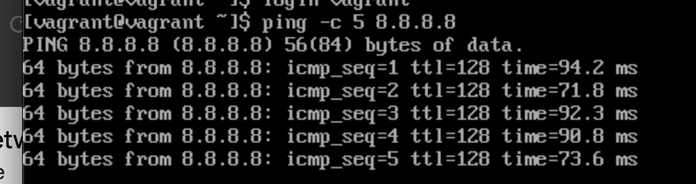

Traceroute Command: traceroute 8.8.8.8

